CHEMISTRY Unit 1 and 2
Fuels Investigation

Aim
To investigate how the length of the carbon chain, within different alcohols effects the amount of energy released during combustion.

You will be provided with the following alcohols:

ethanol, propanol, butanol and pentanol

Task
Carry out an investigation to find out which of these alcohols releases the most amount of energy during combustion.

You have 1 period to carry out this investigation, and complete the investigation task sheet.

You will complete a validation which will be completed in one period. Your task sheet will be collected prior to the validation.

Method

- Fill the conical flask with 100 mL of water. Clamp the flask at a suitable height so that the
spirit burner can be easily placed below.
- Weigh the spirit burner containing the alcohol and record the mass.
- Record the initial temperature of the water using the thermometer.
- Place the spirit burner under the conical flask and light the wick.
- Allow the alcohol to heat the water for 5 minutes.
- Extinguish the flame.
- Record the final temperature of the water.
7. Reweigh the spirit burner and work out the mass of alcohol used. Repeat for different
alcohols. Use 100 mL of new cold water each time.

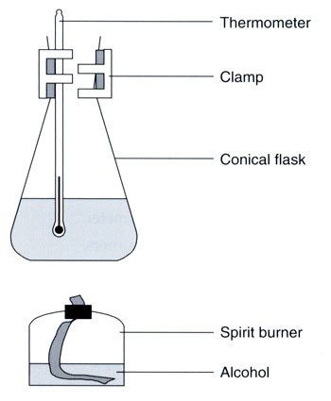

Pre lab Questions

- Identify the independent variable for this experiment.

………………............................................................................................................................
..................................................................................................................................................
- Identify the dependent variable for this experiment and what are the units.

..................................................................................................................................................
……………................................................................................................................................
- Describe at least four variables you are going to control during your investigation.

..................................................................................................................................................
..................................................................................................................................................
..................................................................................................................................................
..................................................................................................................................................
Results table

 | Mass of fuel at start (g) | Mass of fuel at end (g) | Temp at start (ºC) | Temp at finish (ºC)
Ethanol C₂H₅OH
Propanol C₃H₇OH
Butanol C₄H₉OH
Pentanol C₅H₁₁OH

Processing of Results
1. Use your results table to complete the following table.
 | Mass of fuel used (g) | Mass of water (g) | Temp change (ºC) | Energy produced (kJ)
Ethanol C₂H₅OH |  | 100
Propanol C₃H₇OH |  | 100
Butanol C₄H₉OH |  | 100
Pentanol C₅H₁₁OH |  | 100

Energy produced = mass of water x specific heat x temperature
capacity of water difference
(specific heat capacity of water = 4.186 Joule/g°C)

1. Write balanced equations for the four combustion reactions.

2. Calculate the moles of each fuel used and hence the enthalpy change (kJ mol⁻¹) for each fuel.

Conclusion.

